OS File Permissions Outputs

1) Give Read and Write only to the owner
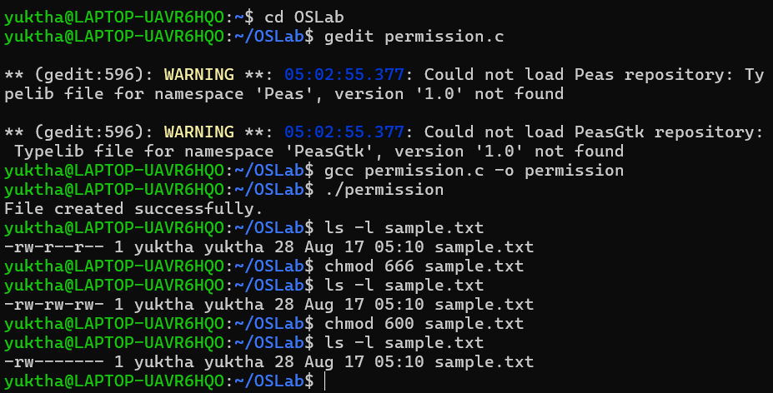

2) Give Read and Write to the owner and group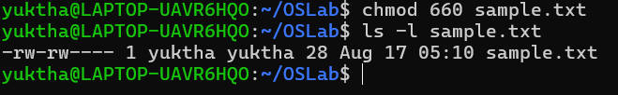

3) Only owner can read and write
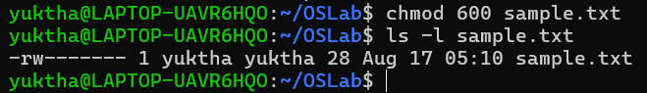

4) Owner read/write, everyone else read-only
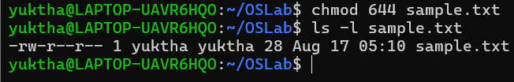

5) Owner can do everything, others can only read and execute
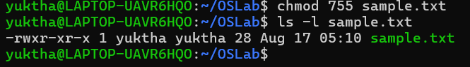

6) Owner and group can read/write
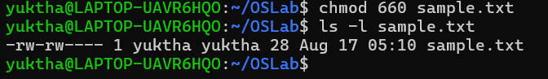

7) Only owner can execute
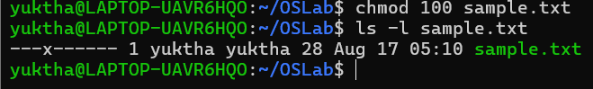

Fill in the permission numbers for the following:
8) Owner: read + write; Group: nothing; Others: nothing →600
9) Owner: read + write; Group: read; Others: read → 644
10) Owner: read + write + execute; Group: read + execute; Others: read + execute → 755
11) Owner: read + write; Group: read + write; Others: nothing → 660
12) Everyone: read only → 444

